q

Airell Rasendriya Bachtiar

airell.bachtiar@student.fontys.nl

Kasintu

Web Collection Game

UX Feedback

Semester 3 - Individual Project

Table of Contents

**1.** **Version** 2

**2.** **Introduction** 3

2.1. Purpose 3

2.2. Definitions, Acronyms, and Abbreviations 3

**3.** **System Overview** 3

3.1. Description 3

3.2. Main User Activities 3

3.3. Project Goal 3

**4.** **Current Design** 4

**5.** **Feedback Methodology** 11

**6.** **Feedback** 11

**7.** **Conclusion** 12

# **Version**

|  |  |  |
| --- | --- | --- |
| **Version** | **Date** | **Description** |
| 0.1 | 25-03-2022 | Make UX Feedback document, document changes with the UX design of the web application. Get feedback from 2 people. |
| 0.2 | 10-06-2022 | Added 2 chapters |
| 1.0 | 16-06-2022 | Version 1.0 of UX feedback document |

# **Introduction**

## Purpose

The purpose of this document is to review the design changes in web application and feedback.

## Definitions, Acronyms, and Abbreviations

* Gacha: A method inspired by toy vending machine where you can get a toy randomly from what the vending machine provide. Instead of toy vending machine, here it is turned into an application game where you can get an item, in this project we called a creature, randomly with a set number of chances.
* Summon or Pull: The action performed when you are getting a creature from the gacha.
* Banner: The place where you summon or pull creature. Banner contains a list of creatures in which the player can obtained and a chance or percentage of how many chances you can obtain a specific creature.

# **System Overview**

## Description

This game is called Kasintu which means bird. Kasintu is a collection-based game where player can collect as much as they want. What they will collect is a different type of birds that is real and fictional thus the meaning of Kasintu is bird, a game where you collect birds. From now on these birds will be called creature.

## Main User Activities

The main feature of this game is called a gacha system. Gacha system is where player can get a chance to receive a virtual item using in game currency. This is where player mainly get a new creature that will be release or has been released by the developer. They called this action of obtaining new creature as a summoning or pulling. In this case we will call this action as summon or summoning. As the where they summoning these creatures is called a banner. A banner contains a certain amount or all the creature available that can be obtained by the player who summoned on that banner.

For a future feature, Kasintu will also include a marketplace and breeding system. Marketplace is where player can but, sell or trade creatures from the other player. Breeding system is where player can breed their own creature to make new creature which may become rarer that the previous creature.

## Project Goal

The goal of this project is to have a game that will entertain user by collecting creatures and to collect everything the game provides. For better user experience, this game will have to has a fast user interface to make user does not need to wait long in between action or input and a secure application so that data from user cannot be tracked or stolen by a third party.

# **Current Design**

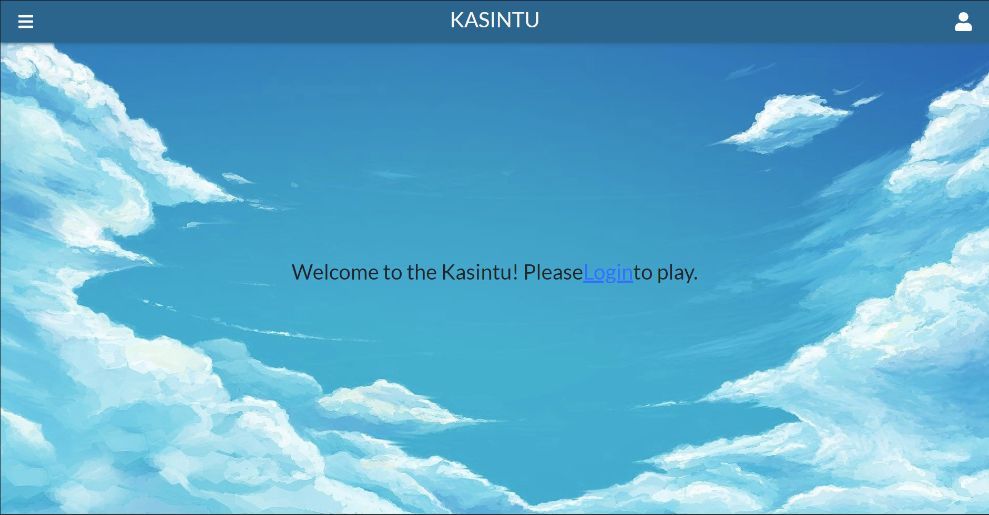

Figure 1 Homepage Before Login

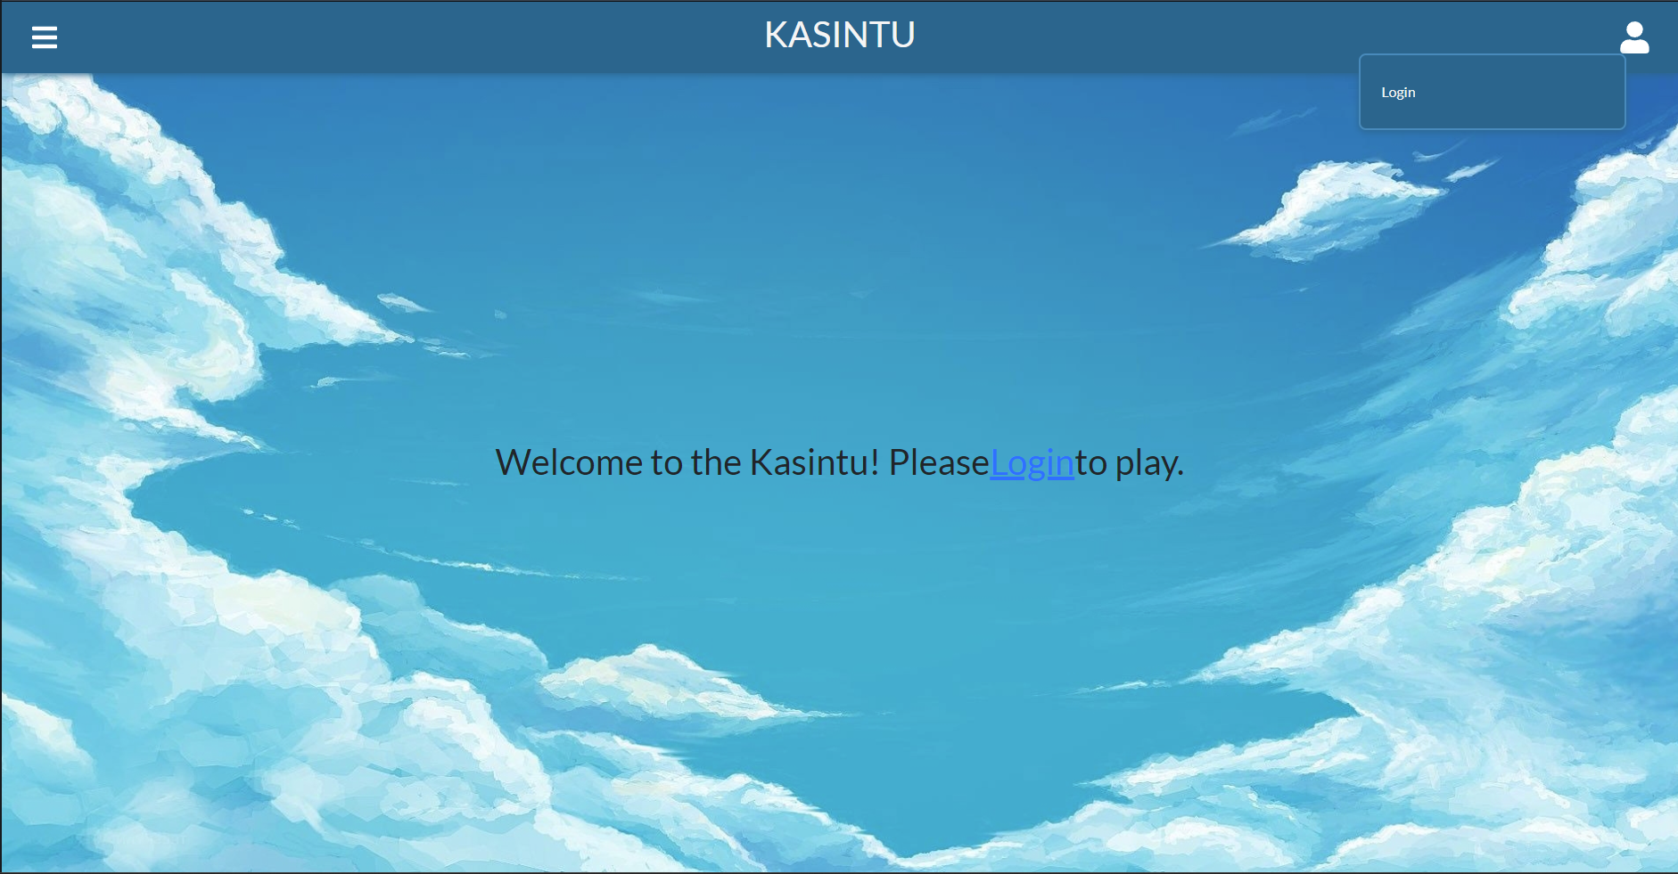

Figure 2Profile Menu Before Login

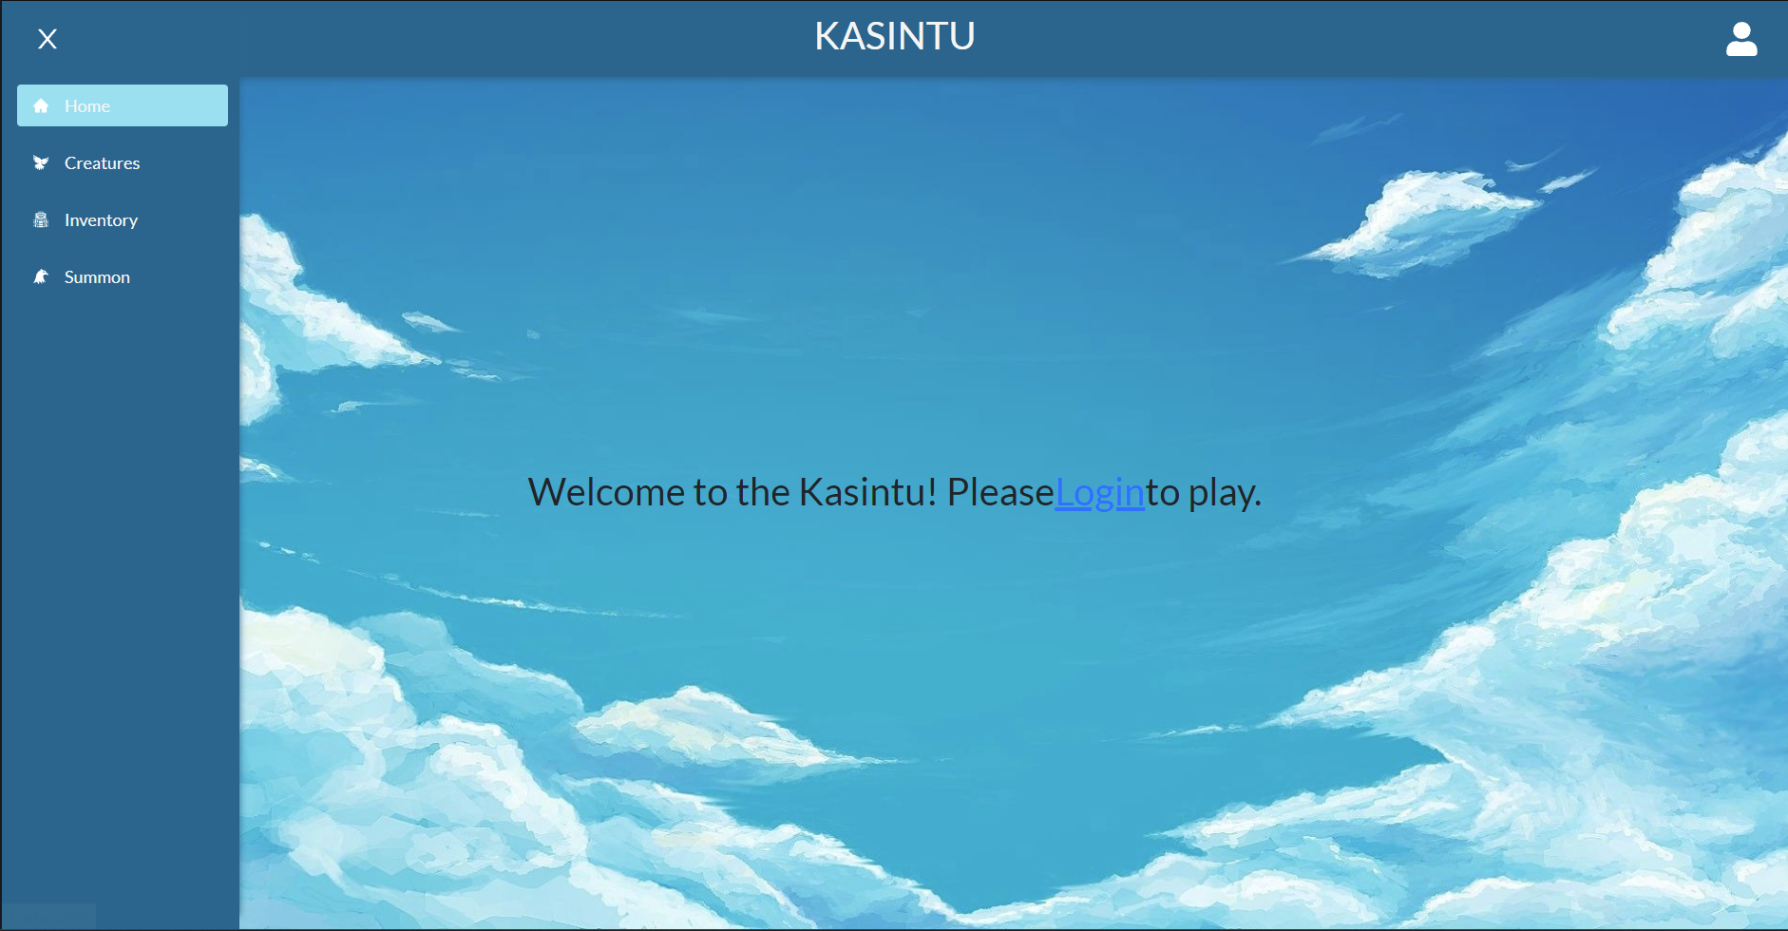

Figure 3 Navigation Bar

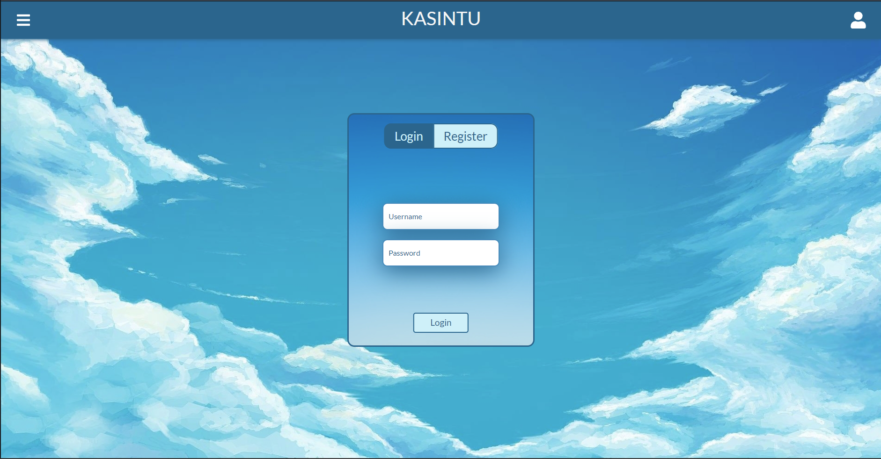

Figure 4 Login Page

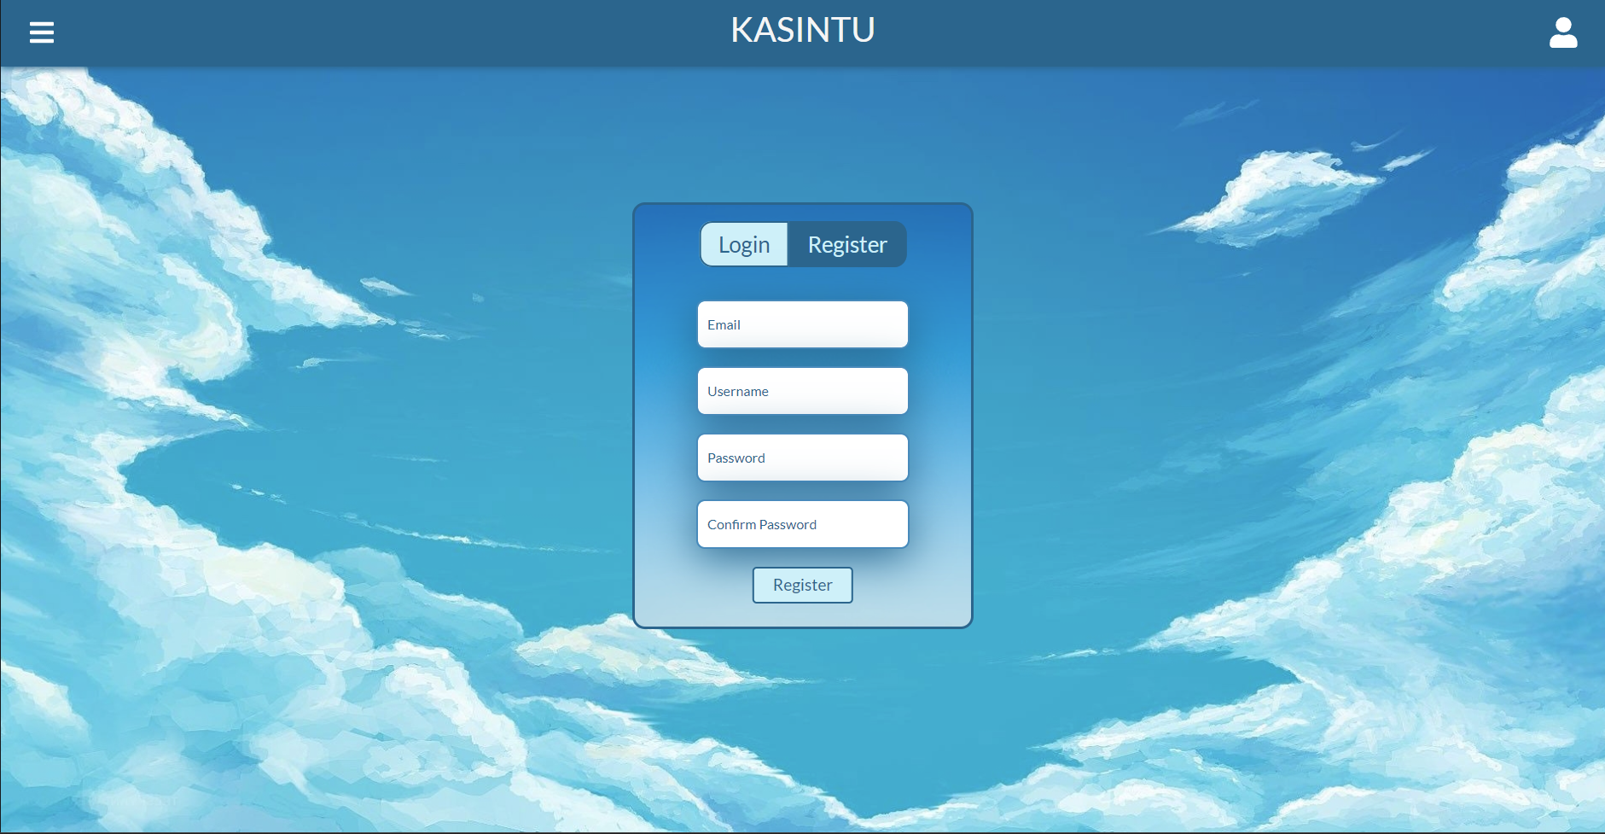

Figure 5 Register Page

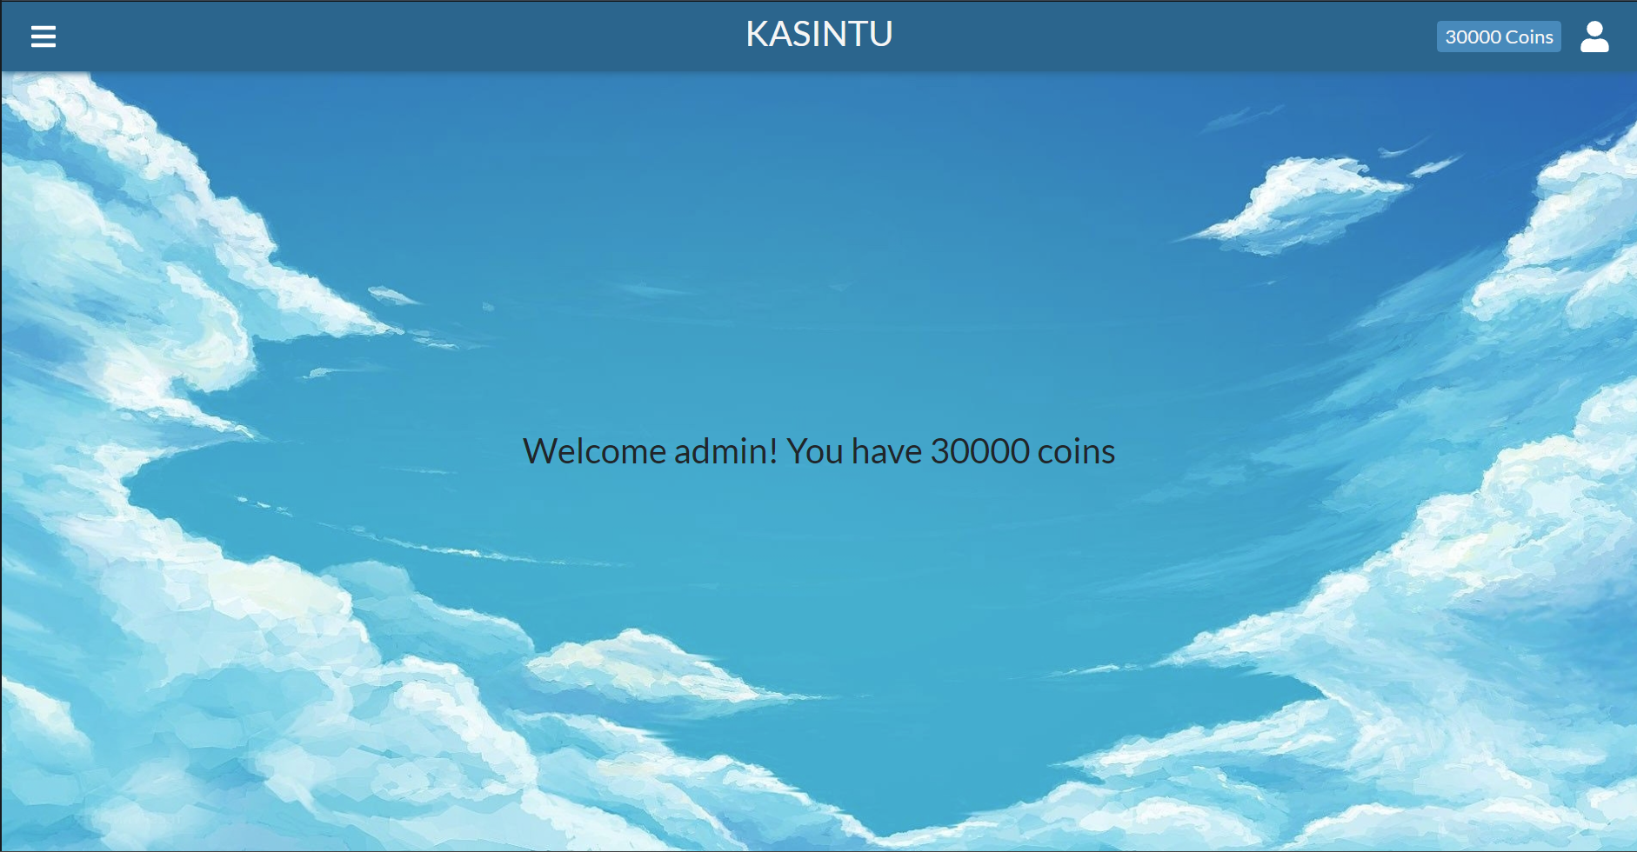

Figure 6 Homepage After Login

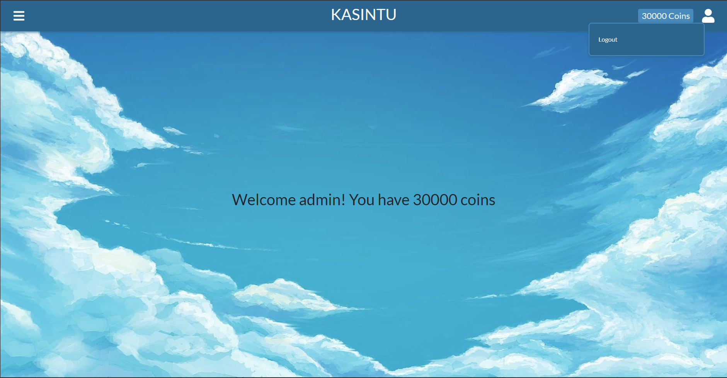

Figure 7 Profile Menu After Login

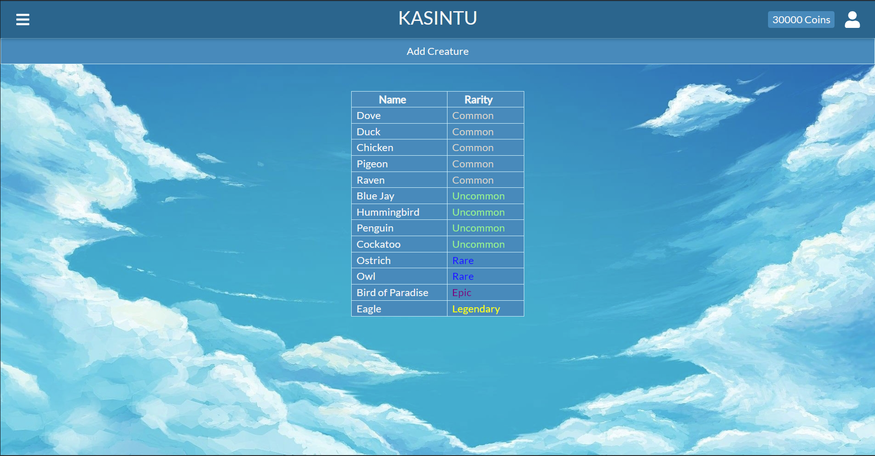

Figure 8 Creatures Page

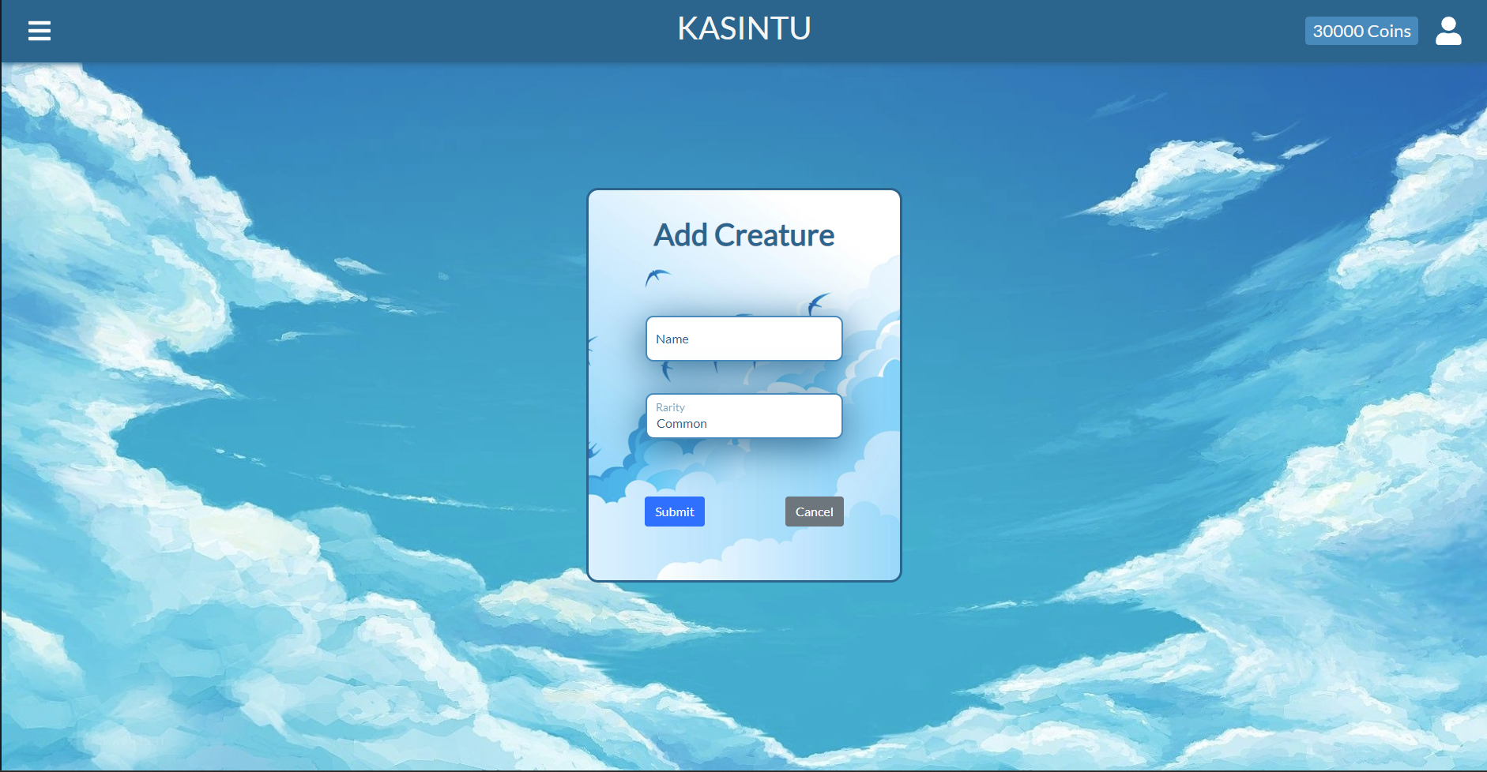

Figure 9 Add Creature Page

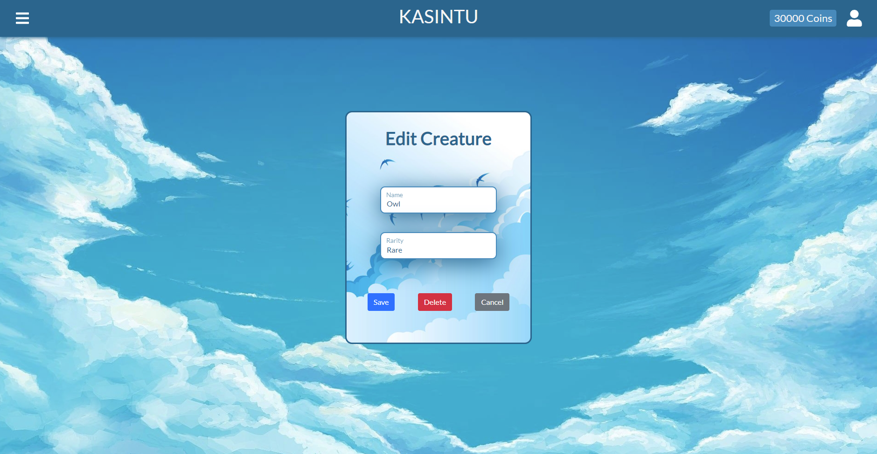

Figure 10 Edit Creature Page

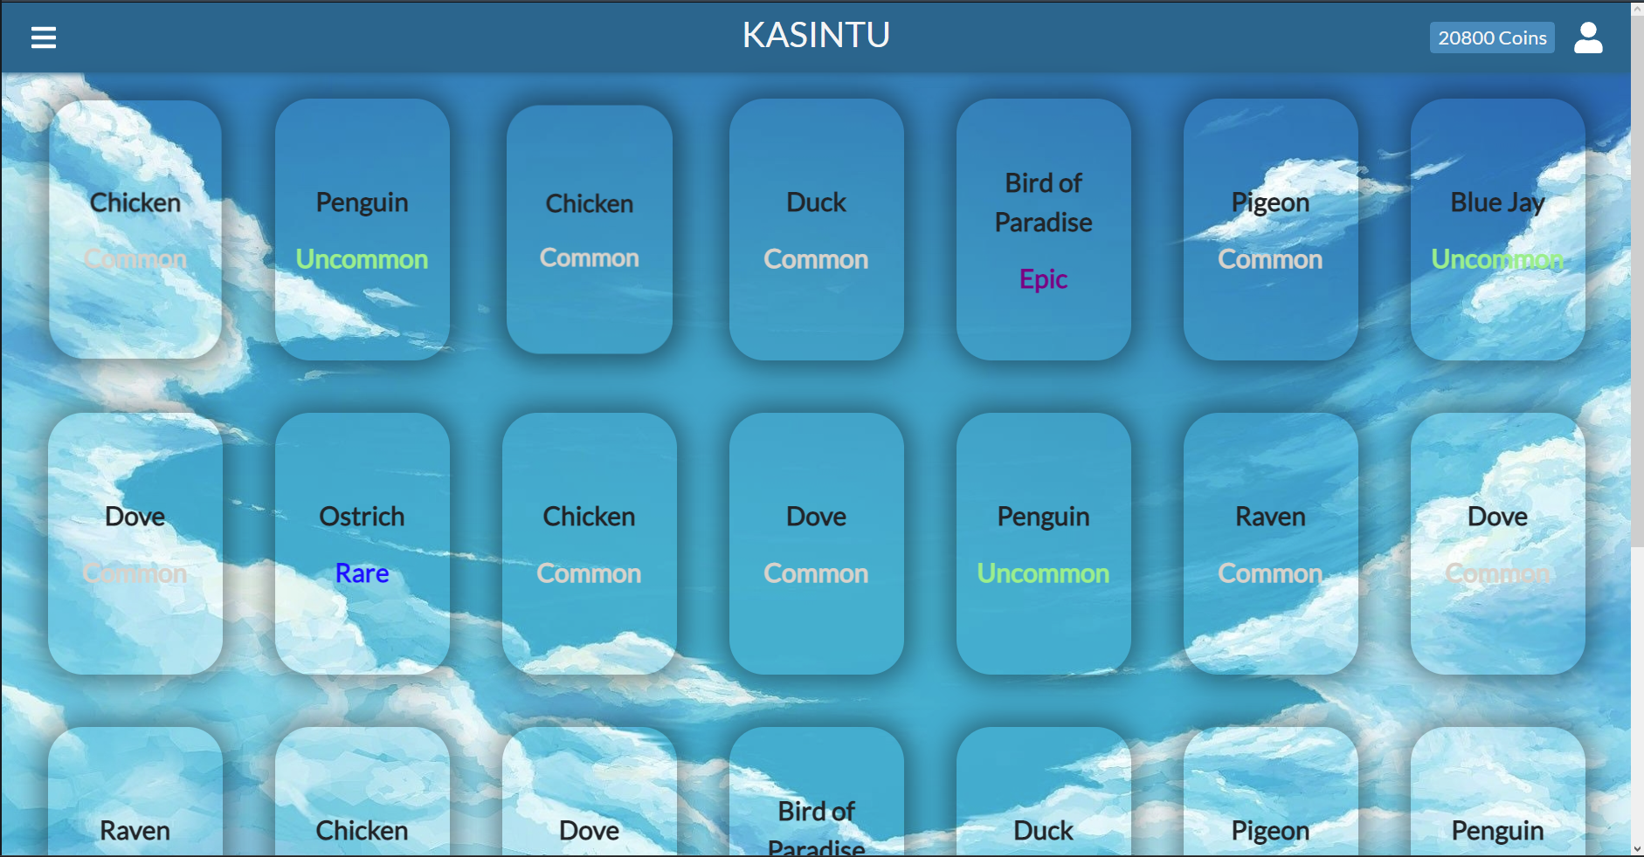

Figure 11 Inventory Page

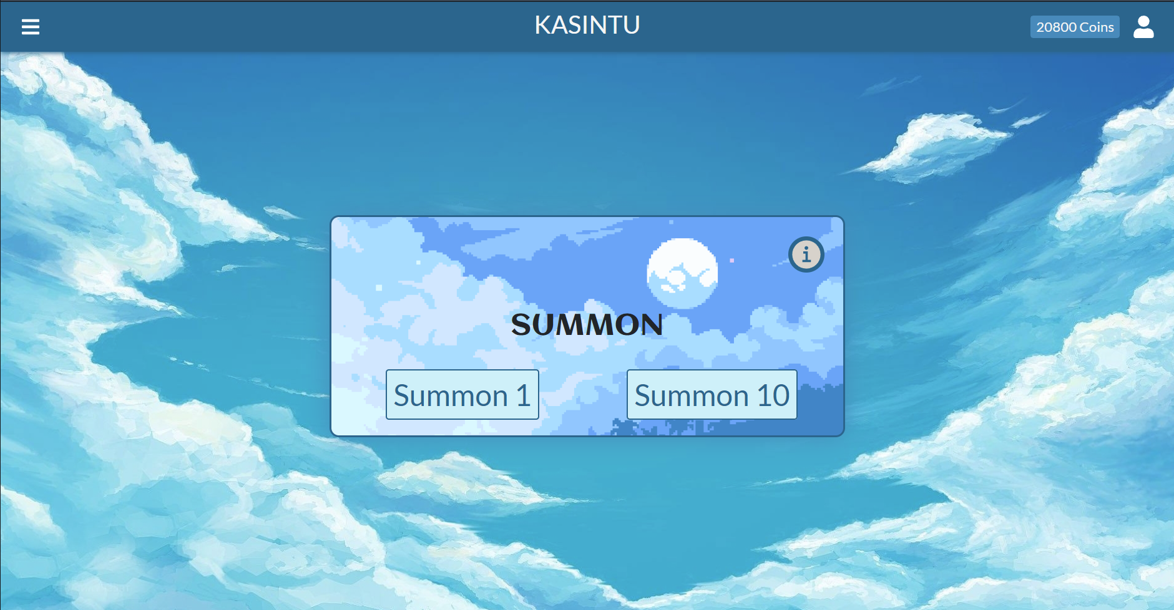

Figure 12 Summon Page

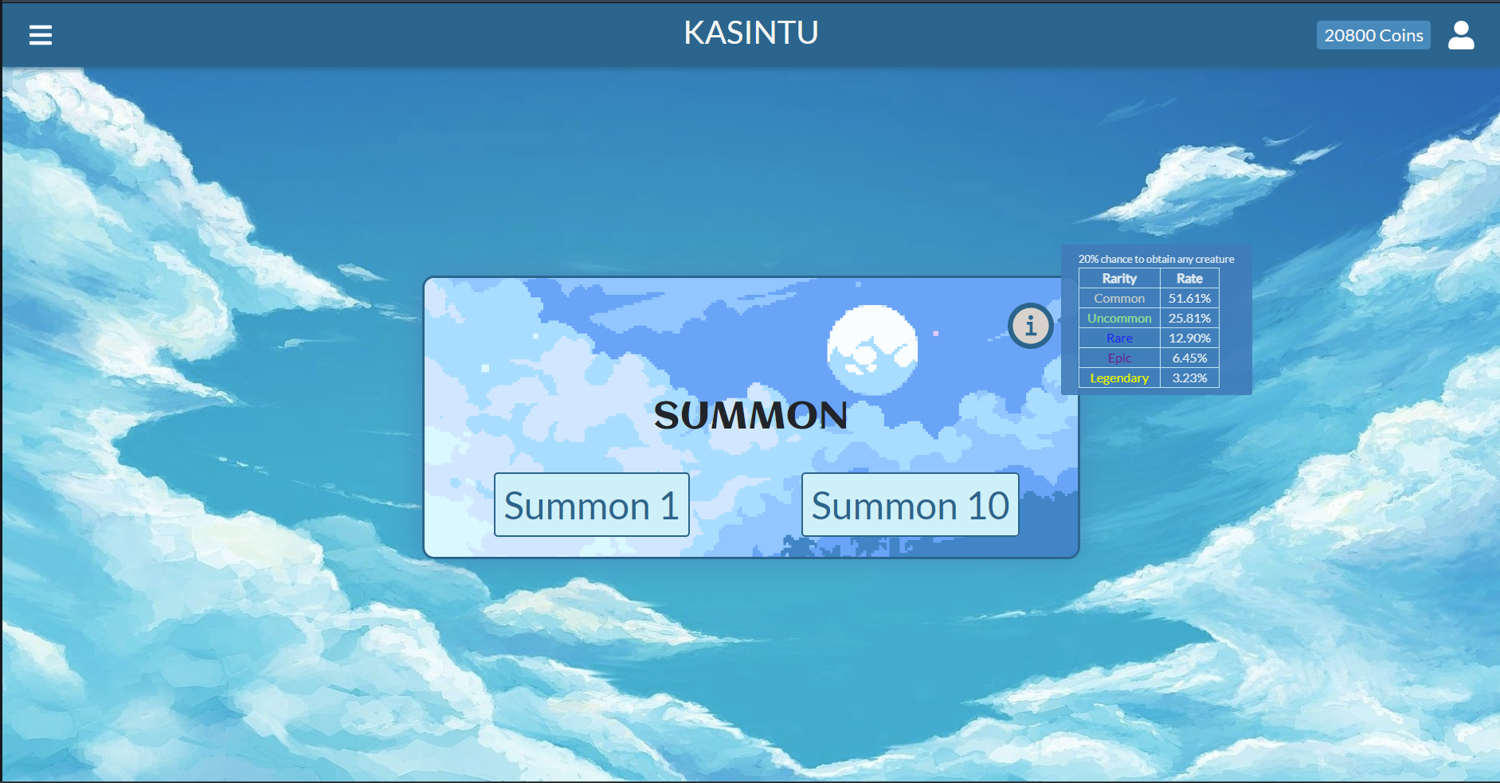

Figure 13 Summon Page with Information Displayed

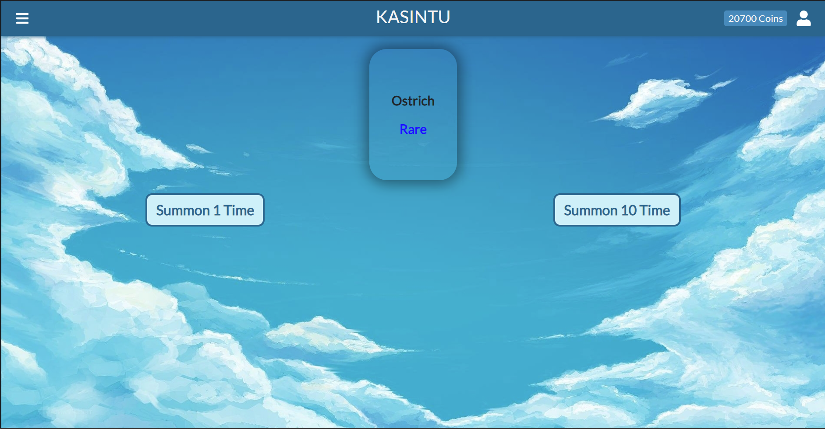

Figure 14 Summon Once Page

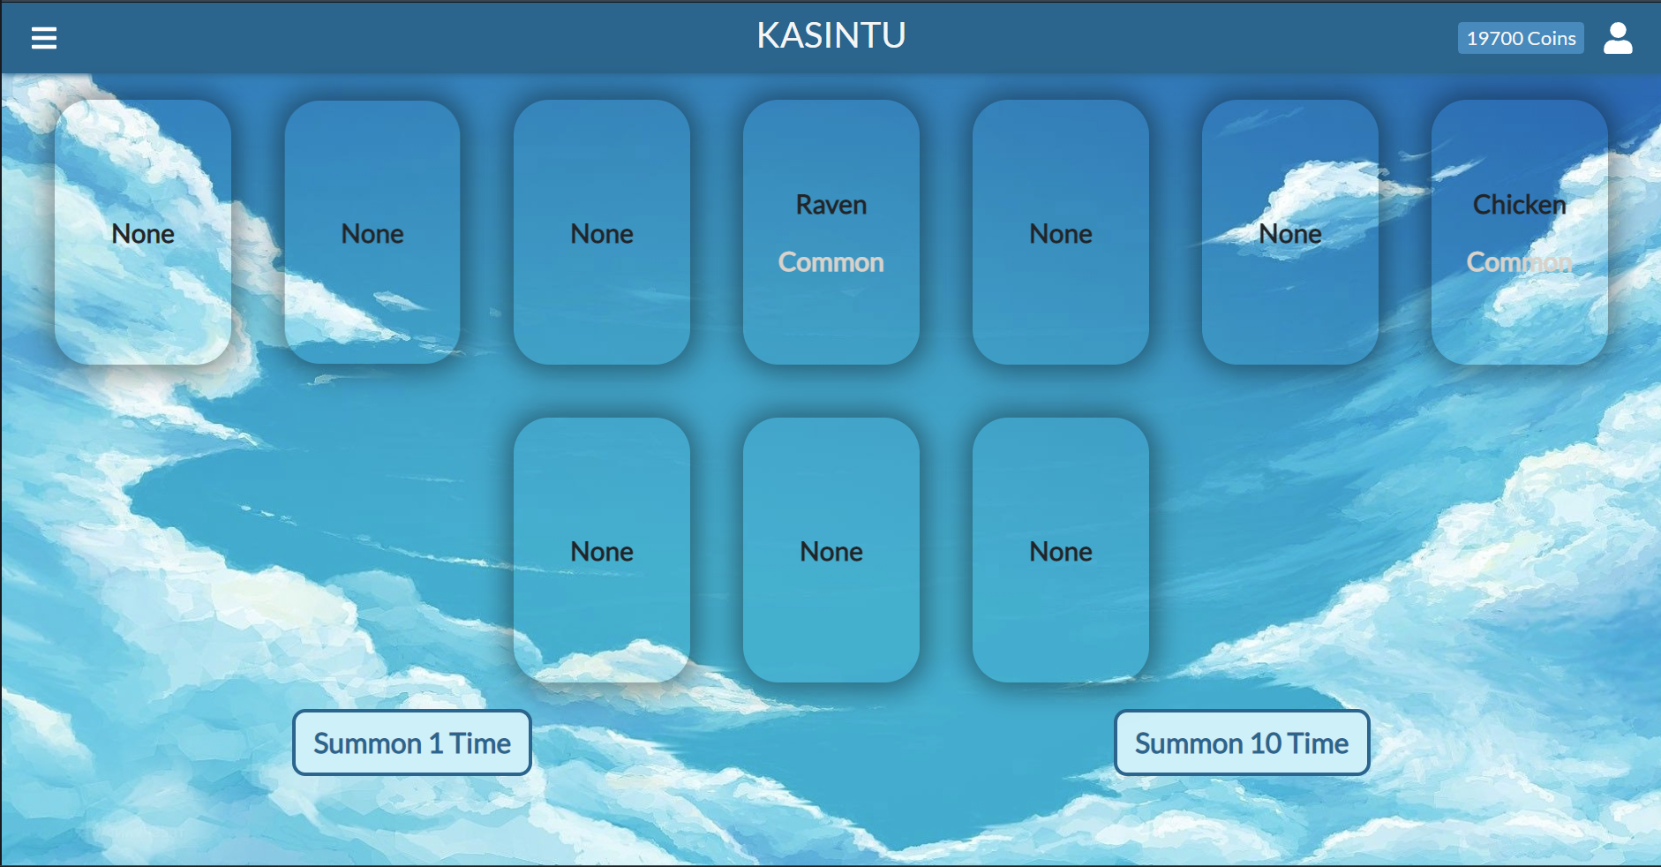

Figure 15 Summon 10 Times Page

# **Feedback Methodology**

Participants that test and review the web application can move freely and do whatever they want. The only instruction given is to summon creatures as the main feature for this game. Newly registered player will be given plenty number of coins as the currency so that they can summon multiple time as before, 1000 coins will be given automatically and with that, they can only summon 10 times. Number of coins given will be varied between 10,000 to 30,000 coins.

They can give the feedback during and/or after they played the game. Feedback from them will be noted and written in this report.

# **Feedback**

Due to privacy reason, participants’ name, location, and age will not be mentioned. Since there are 2 participants, they will be mentioned as Person A and Person B. The only similarity they have is their age, they both roughly at the same age. The reason for the participants close age is due to the target audience for this game is at the age of the participants. The target audience for this review is teenagers to young adults.

Person A is an Asian woman who currently living in Southeast Asia. She has an experience in design from her role as the lead designer for social media advertisement in her private project and is an amateur photographer.

Person A play the game through a remote controlling a computer since the game cannot be accessed beside local host. The features she tried includes the following, sign in and login to the web application, view all creatures, view more detailed creatures, view her own inventory, and summoning. From the demo she performed, she made the following remarks:

1. Add an information on how much the summoning cost
2. Give more design to the home page before login and make new home design after login that is better than the home page before login. Her reason for this approach is to make player wants to go back to the web application again.
3. If possible, the card creatures could be better if there are picture instead of words and give the rating some animation to differentiate between the name of the creatures and its rarity
4. If login token expired, the web application automatically logged out and display the login form. It would be better if the web application can tell the players that they are logged out by the system
5. Make the inventory tidier and separate the creatures between rarities
6. Add summon animation of obtaining rarer rarity for instance, add fireworks next to the creatures’ card. The rarer the rarity is, the bigger fireworks animation will be.

Person B is a white male who currently living in the Northwest Europe. He is experienced in programming and has made few programming projects and it includes making a web application. He is familiar with how the user interface of a web application should be and currently he is studying UX design.

Person B play the game using a computer from local host. The features he tried includes, sign in and login to the web application, view all creatures, view his own inventory, and summoning. From the demo he performed he made the following remarks:

1. Information of banner on hover should stay if the cursor is hovering on top of the information text
2. When refreshing the page, player should be able to stay logged in
3. Creatures’ card can be better especially the rarity part since it can be easily unreadable if the background is in similar colour
4. If player doesn’t have any creatures in player’s inventory, system should notify player that they don’t have any creature in their inventory

# **Usability Heuristics**

|  |  |
| --- | --- |
| **Heuristic** | **Applied** |
| Visibility of System Status | YES |
| Match Between System and the Real World | YES |
| User Control and Freedom | YES |
| Error Prevention | YES |
| Help Users Recognize, Diagnose, and Recover from Errors | YES |
| Consistency and Standards | YES |
| Recognition rather than Recall | YES |
| Flexibility and Efficiency of Use | YES |
| Aesthetic and Minimalist Design | YES |
| Help and Documentation | NO |

(Jain, 2015) (Nielsen, 1994)

Visibility of system status means that system should keep users informed about the current state and actions. This heuristic is applied in Kasintu. The system will show a loading animation whenever the system is communicating with the server.

Match between system and the real world means that system should speak the users’ language, with words, phrases and concepts familiar to the user. The other word is, system should include the real-world behaviour that is logical and natural so it is easier for the users to understand. This heuristic is applied in Kasintu. Kasintu website use logos that resemble the meaning of the option. In the navigation bar, there is a home icon that user can click and it navigate to the home page.

User control and freedom means that digital spaces need quick “emergency exits” just like physical spaces do. For example, a system should support undo and redo if the users make a mistake and wish to go back to the previous state. This heuristic is applied in Kasintu in editing profile page. There is a cancel button when users want to cancel the editing profile process.

Error prevention means that system will show an error message that can prevents a problem from occurring in the first place. This heuristic is applied in Kasintu. If users registered and input the wrong email or leave inputs blank, system will tell the users to input the correct credentials.

Help users recognize, diagnose, and recover from errors means that error messages should be expressed in plain language and indicate the problem. This heuristic is applied in Kasintu in login page. If the users submit the wrong username and password, the system will tell the users if the login has failed.

Consistency and standards mean that users should not have to wonder whether different words, situations, or actions mean the same. This heuristic has been taken into consideration at the start of the project and has been applied in Kasintu. This heuristic can be viewed in adding or editing a creature. The form for adding or editing is the same to preserve design consistency in the system.

Recognition rather than recall means that system should minimize the user’s memory load by making objects, actions and options visible. This heuristic is applied in Kasintu in login page or register page. Those pages will display a label in each input to show what input the users needed to insert.

Flexibility and efficiency of use means that system should provide a shortcut that may speed up the interaction or allow users to tailer frequent actions. This heuristic can be implemented by using a keyboard shortcut to speed up a certain process and it is applied in Kasintu in forms. Every form in Kasintu, e.g., login form, register form, edit profile form, etc. can be submitted by pressing enter instead of clicking the submit button.

Aesthetic and minimalist design means that system should have a clean minimalist design. This heuristic has been taken into consideration at the start of the project and has been applied in Kasintu as the main goal of the UI design. The website will not show the users irrelevant information and make everything simple but recognizable. For example, the creature description will not be displayed in the list or the card and only be displayed in detailed page of a creature.

Help and documentation means that system should provide documentation to help users understand how to complete their tasks. This documentation is not implemented in Kasintu because it is not listed in the product backlog and time constraint.

# **Changes**

Based on the feedback and usability heuristics. Design of the web application has been changed. Here is the list of feedback and whether it is implemented or not.

|  |  |
| --- | --- |
| **Feedback** | **Applied** |
| Summoning cost | YES |
| Home page design | YES |
| Picture in creature card | NO |
| Show login form if the user token expired | YES |
| Tidier inventory | YES |
| Summon animation | Partially |
| Banner info stays if the cursor is on top | YES |
| User stays logged in if the page is refreshed | YES |
| Improve the card so it is readable | YES |
| Show information if the inventory is empty | YES |

Having a picture in creature card can be done but due to time constraint and searching/making each creature is time consuming. Creature card should have consistent design and the easiest way to do it is by creating it. Due to time constraint, it is not possible.

Summon animation is partially done. Now the website features an animation when users is summoning however, the feedback implied that the animation should be grand if user got rarer creature. This is not implemented due to time constraint because animation has to be made and it will take quite a time.

# **Conclusion**

Web application needs to be changed based on the feedback given. Some feedback may not be implemented because of the implementation is out of scope and/or due to time constraint. For example, adding a picture instead of text will not be implemented.